**Task # 03: Write step how to install visual studio.**

**SOLUTION:**

**Step 01:** first of all we go to the visual studio official website.

Go to: <https://visualstudio.microsoft.com/vs/community/>

**Step 02:** Then where click on the download button.

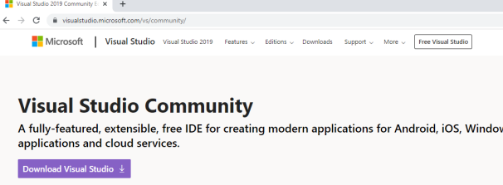

**Step 03:** After clicking on download then start the application

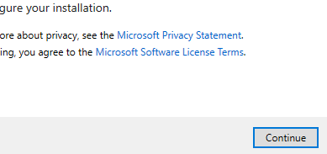

**Step 04:** When the file has been downloaded then click continue the visual studio installer will start

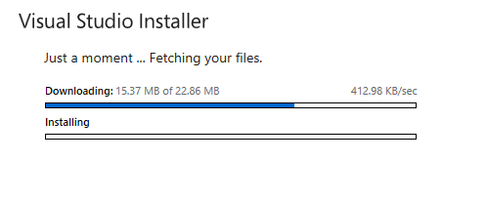

**Step 05:** Select the workload whatever you want.

**Step 06:** The visual studio installer will start.

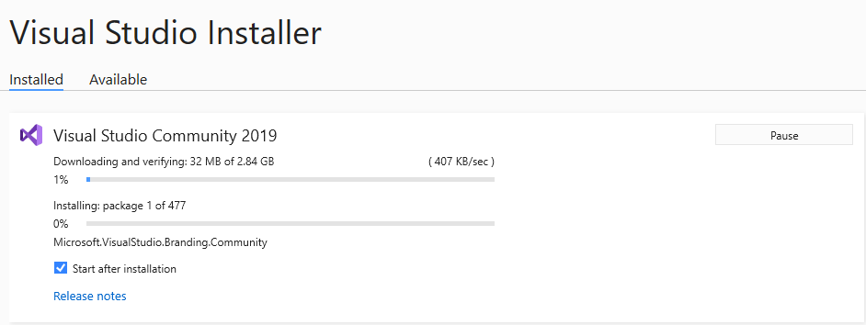

**Step 07:** After installing open visual studio create new project and start programming

